**Using sources – how did the role of women change?**

1. For each picture write a sentence to explain what the poster is trying to encourage women to do.

If you are stuck – look at the ideas at the bottom of the sheet. You can copy and paste relevant ideas into the text box underneath to the picture.

1. What do these sources show us about how women’s role (and attitudes) changed over time?

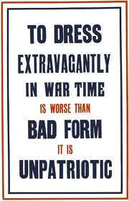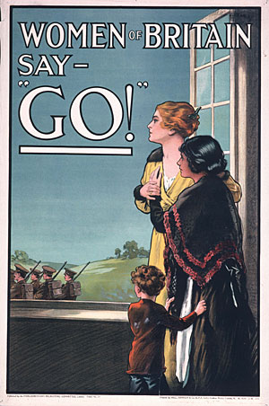Source 1 Source 2 Source 3

Ideas for Source 3

Women work in the kitchen

They should try to not be wasteful

Ideas for Source 1

Encouraging women to tell their husbands to go to war

Women’s role was to stay home

Ideas for Source 2

Women should be humble

They heavily influenced men

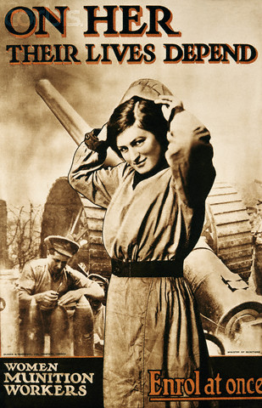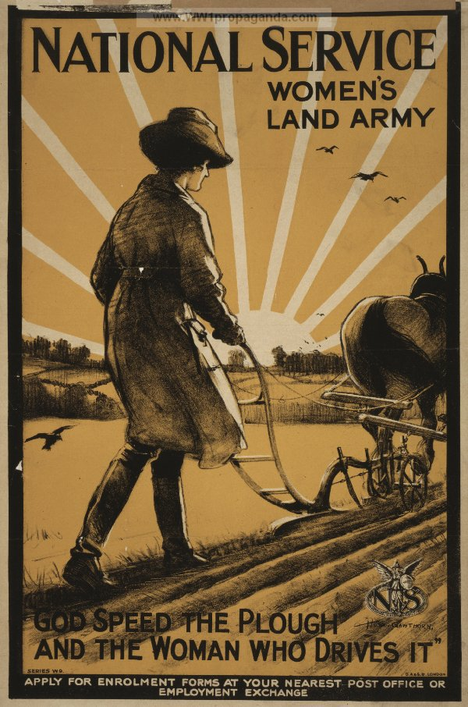Source 4 Source 5

Ideas for Source 5

A woman’s main role during war was just staying at home in the kitchen

Ideas for Source 4

They were told to take on the original role of men

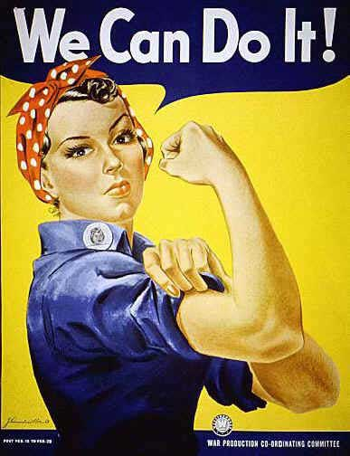Source 6

Ideas for Source 6

Women were encouraged to replace men in their roles

Women were seen as stronger

**Here are some ideas you could use if you are stuck. They can help you with both questions.**

Women were encouraged to not be wasteful.

Women were encouraged to save and donate money to the war effort.

Women were encouraged to take on the traditional roles of men.

Women were expected to encourage their partners to join enlist for war.

Women were given a new sense of capability and importance.

Women were manipulated.

Women were seen as having a powerful influence on men.

Women were seen as holding men back from enlisting.

Women were seen as not really understanding the sacrifices men were making.

Women were seen as stronger.

Women were still seen in a stereotypical way.

Women’s lives were seen as easier than men’s.

Women’s main role in helping the war effort was in the home.